Features of Java->

1.simple->

syntax is based on c++,Features of Java.

2.object-oriented->hava all the properties.

1. Object->
2. Class
3. Inheritance
4. Polymorphism
5. Abstraction
6. Encapsulation

3. Platform Independent->

A platform is the hardware or software environment in which a program runs.

The Java platform differs from most other platforms in the sense that it is a software-based platform that runs on the top of other hardware-based platforms. It has two components:

1. Runtime Environment
2. API(Application Programming Interface)

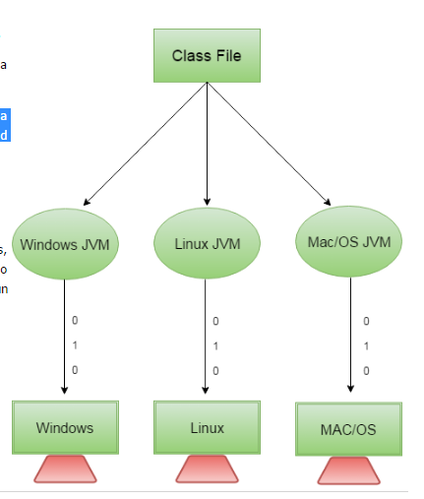

3.Secured->

Java is secured because:

**\*No explicit pointer.**

**\*Java Programs run inside virtual machine sandbox.**

* **Classloader:** adds security by separating the package for the classes of the local file system from those that are imported from network sources.

*Bytecode Verifier: checks the code fragments for illegal code that can violate access right to objects.

4.Robust->

**Robust simply means strong. Java uses strong memory management. There are lack of pointers that avoids security problem.**

**5.Portable->**

**It can run on any platform.**

**6.High performance->**

**Java is faster than traditional interpretation since byte code is "close" to native code still somewhat slower than a compiled language (e.g., C++).**

**7.mulit threding->**

**Multi tasking**

**1.process based multitasking-**

**2.thred based-executing servals parts of program on same time. Which does not depends on each Other.**

**3.thread means simply a program or task.**

**C++ vs Java->**

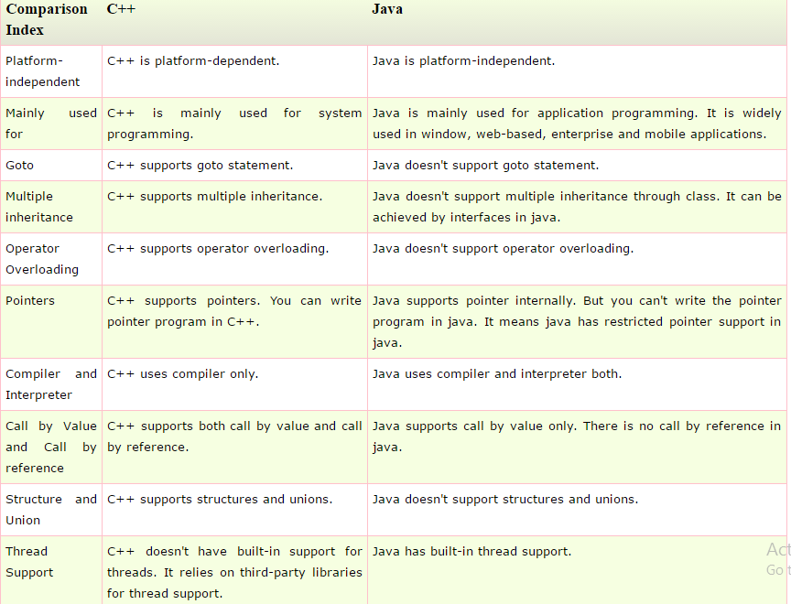

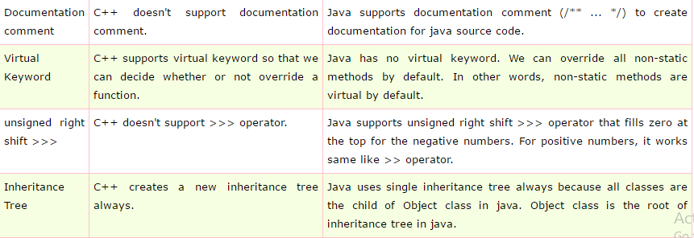

**properties.**



